Vintage 2021

Coming out of two dry growing seasons back-to-back, the winter of 2020 was unseasonably warm and delivered multiple heavy rain events.
Due to the hard and fast nature of the winter rains, the clay soil under the vines remained reasonably dry. The vines only needed the slightest hint of a change in season and burst bud early. Spring turned out to be very dry allowing for great flowering whilst restricting vegetative growth. The dry theme continued into summer with low disease pressure however by the end of December, moderate levels of water stress was visible in the vines. The favorable working conditions allowed for the summer canopy work to be completed shortly after the New Year. Nets were then put out in earnest as the myna birds took up residence pestering the blocks.

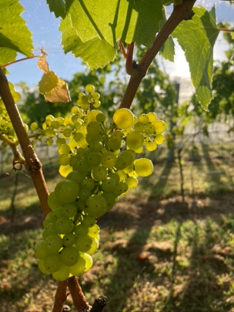
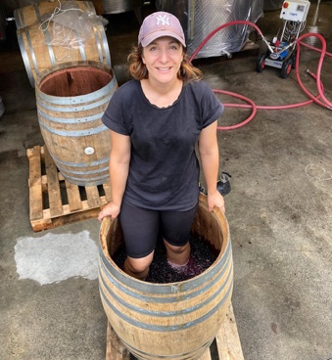 | 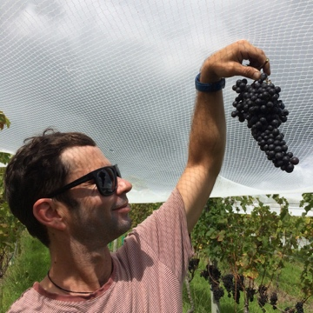
Average rain during January helped to keep the vines functioning and by early February the Chardonnay was ready to pick- pure, zesty and immaculate in condition. As the harvest progressed persistent showers and morning dews led to some shriveling but nothing of qualitative concern. The Cabernet Franc was the star of the reds, deliciously ripe and blue- black in colour. Finally, the season ended with the harvest of the Cabernet Sauvignon at the end of March, the nets were stowed away and a kind introduction to Northland winegrowing was reflected upon.

